Name:

ID:

Web Programming

Chapter 4 (Part 2)

<http://runestone.academy/runestone/books/published/webfundamentals/CSS/toctree.html>

1. Consider the following:

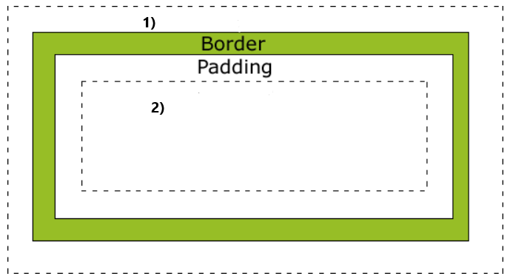

* What is this model called?
* What is the #1 space named?
* What is the #2 space named?

1. Consider the following CSS and HTML:

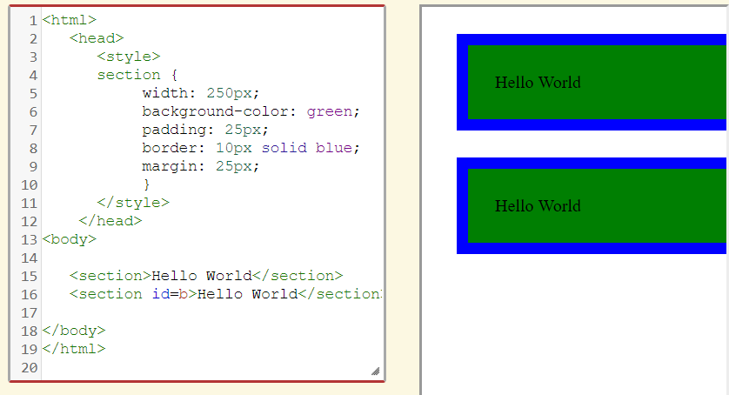

* How can I change the size of the green rectangles?
* What if I want the green rectangles to be gold?
* How can the blue rectangles become smaller and orange?
* What HTML tag are the green and blue rectangles?

1. What keyword can be used so that the browser can figure out the proper height or width for an element?
2. Height, Max-Height, Width, Min-Width are examples of properties that can modify the size of an element. Complete the following table so that the size units are named properly:

|  |  |
| --- | --- |
| unit | name |
| % |  |
| px |  |
| pt |  |
| vh |  |
| vw |  |

1. What value should be set on the *display* attribute of an HTML element so that it is not visible?
2. What is meant by the term floating?
3. Match the following CSS positioning terms:
4. Static
5. Fixed
6. Relative
7. Absolute

|  |  |
| --- | --- |
| position | definition |
|  | Default positioning value for the css position property. The ____ value simply tells the browser to position this element in the “normal flow” of the document. |
|  | Elements with a _____ position value do not move even when the contents of the browser window are scrolled. The navigation bar at the top of this page uses the _____ position value so it is always visible. |
|  | Using a _____ position value lets you create elements that overlap each other. |
|  | ______ positioned elements are positioned outside the normal flow of the document. |

1. Explain the following CSS:

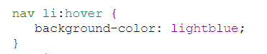

1. Explain the following CSS:

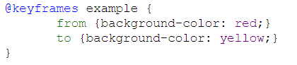

Exercises

Go to the exercises section for HTML and CSS and complete the following exercises from the book. Paste a screenshot of your code as your answer.

Part 1: [HTML](http://runestone.academy/runestone/books/published/webfundamentals/HTML/exercises.html)

1. #6
2. #8
3. #9

Part 2: [CSS](http://runestone.academy/runestone/books/published/webfundamentals/CSS/exercises.html)

1. #1
2. #2
3. #5